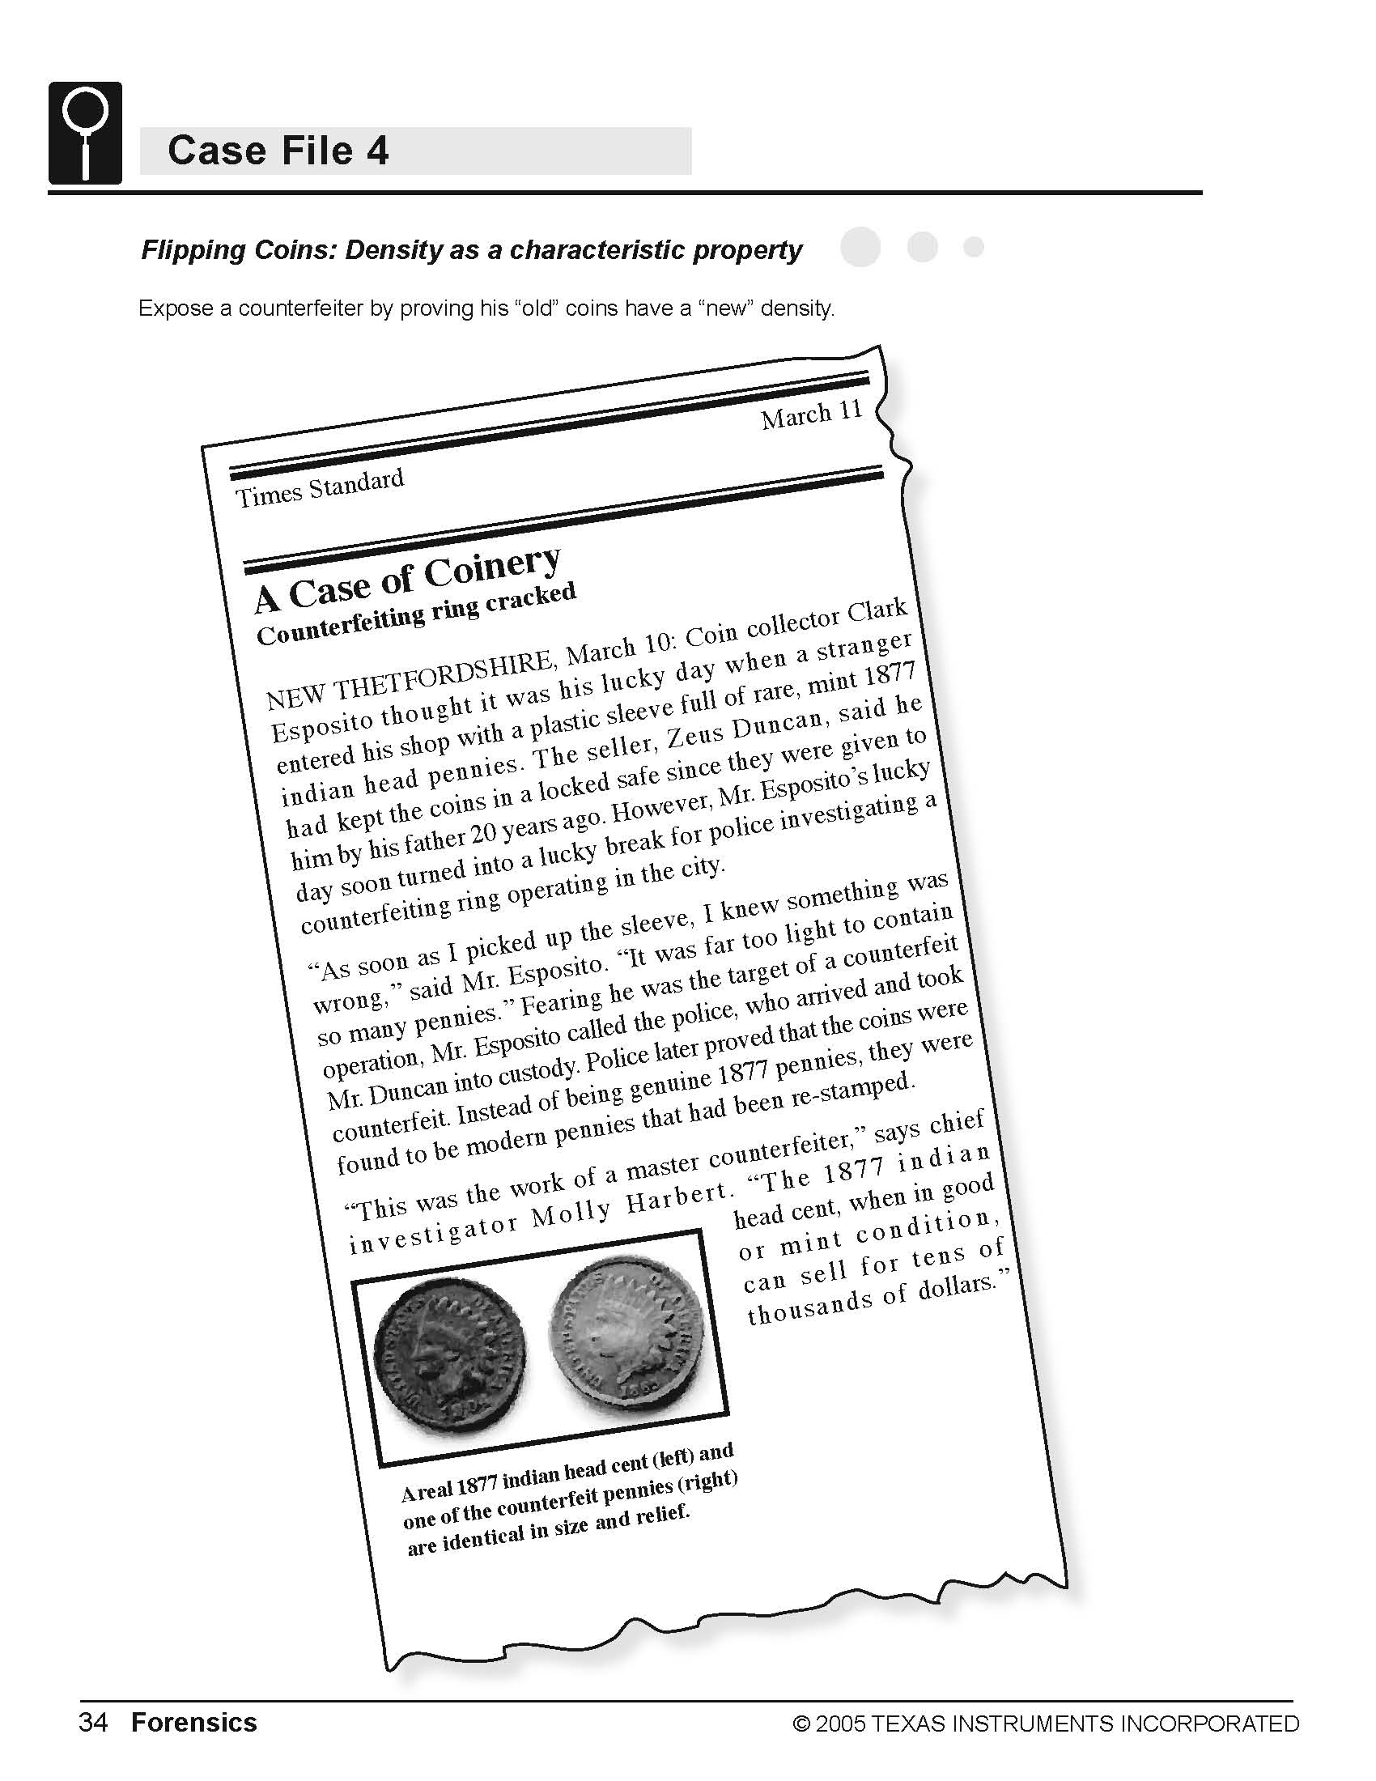
Objectives
- Identify counterfeit coins based on the characteristic property of density.
- Model data using a linear equation.
- Interpret the slope and intercept values from a linear model.
- Identify a characteristic property of a substance.

Activity Materials
- TI-NspireTM technology  - Case 4 Flipping Coins.tns file  - Vernier EasyLink™ or TI-Nspire Lab Cradle  - Vernier Dual-Range Force Sensor  - clamp or heavy tape | - small cup  - 20 pennies dated 1963–1981  - 20 pennies dated 1982  - 20 pennies dated after 1982
Procedure
Open the TI-Nspire document Case 4 FlippingCoins.tns.  In this data-gathering activity, you will identify counterfeit coins based on the characteristic property of density. |  | 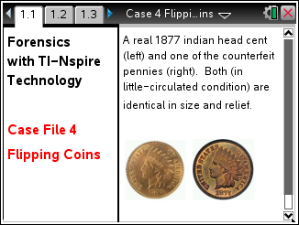
Part 1 – Preparing for Analysis
1. Separate each group of 20 pennies into four stacks of 5 pennies each. As you do this, confirm that you have 20 pre-1982 pennies, 20 pennies dated 1982, and 20 post-1982 pennies.
2. Set the range switch on the Dual-Range Force Sensor to ±10 N.
3. Secure the Force Sensor to the edge of a table. The sensor must be positioned with the hook closest to the ground and should remain level at all times. The figure below shows how the equipment should be set up.
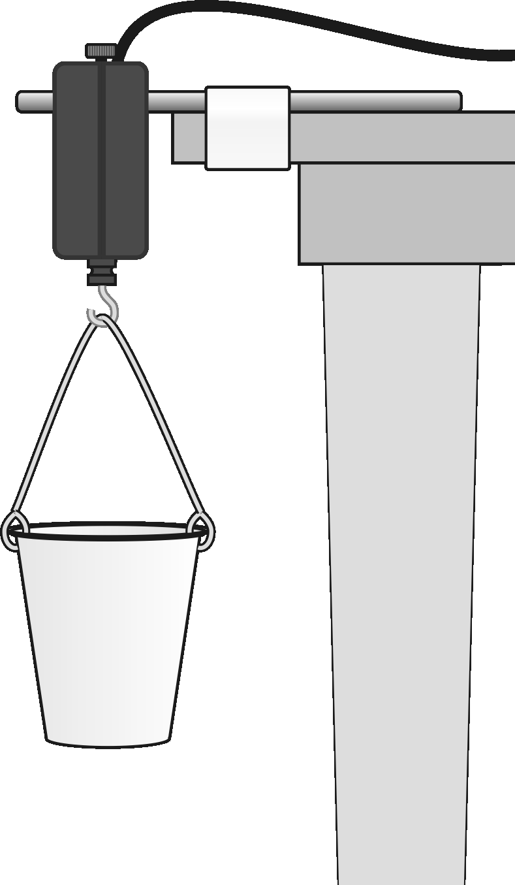

Part 2 – Collecting Data
Move to page 1.2  4. Connect the Dual-Range Force Sensor to TI-Nspire using EasyLink or the Lab Cradle. | 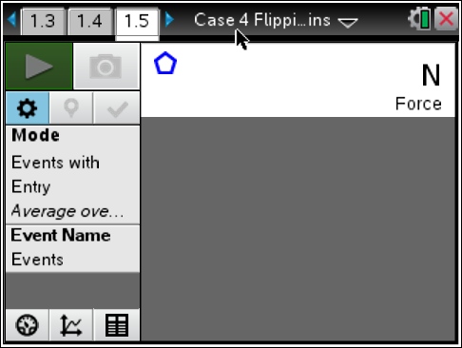
5. Hang the empty cup from the hook on the Force Sensor.

6. You are now ready to record the weights of different numbers of pennies.
a. The empty cup should be hanging from the hook on the force sensor. Start data collection by clicking the button.
b. When the weight reading of the empty cup is stable, select the keep icon to keep current reading.
c. Enter 0 for the number of pennies now in the cup and press OK.
d. Place five of the pre-1982 pennies in the cup, and wait until the reading is stable.
e. Select “Keep” and enter 5, or the number of pennies in the cup. Select OK.
f. Continue with this procedure, using increasing numbers of pre-1982 pennies, in 5 penny increments with 20 pennies as the last point.
g. Stop data collection when you have finished collecting data by pressing the stop button. Your screen shows a graph of force vs. number of pennies. The graph should be linear. If you want to repeat data collection, repeat Steps 6 and 7.
Part 3 – Analyzing the Data
Move to pages 1.9 – 1.10.
17. To determine the equation that describes the relationship between weight and number of pennies, add a linear fit to your data.
- Press MENU > Analyze > Curve Fit.
- Select Linear for the Fit Equation. The linear-regression statistics for these two data columns are displayed for the equation in the form
y = mx + b
where x is the number of pennies, y is the weight, m is the slope, and b is the y-intercept. A best-fit linear regression line will be shown for your five data points. This line should pass near or through the data points.

- Record the equation and values for the best-fit line in your Evidence Record and select OK.
- Select the file cabinet icon to store this data. You should notice that the run number says run 2 and the color has changed.

8. Repeat Steps 6–7 for the pennies dated 1982.
9. Repeat Steps 6–7 for the pennies dated after 1982.

